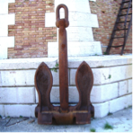
Eighth French Philosophy of Mathematics Workshop (FPMW 8)
Thursday, November 3, 2016 - Saturday, November 5, 2016
Université d’Aix-Marseille, 3 place Victor Hugo 13001 Marseille

Registration Form
(to be sent to the following address : fpmw8-2016-organization@sciencesconf.org)

Name
Affiliation
Arrival date
Departure date
Social Dinner on Friday November 4 (fee to be paid directly at the restaurant, reservation needed by October 15, 2016) YES (alone = 40€/ + 1 GUEST = 80€ / NO)
Dietary restrictions
Other information

